Git Bash Commands:

HP@DESKTOP-RD6TT5J MINGW64 ~

$ cd C:/Users/HP/GitDemo

HP@DESKTOP-RD6TT5J MINGW64 ~/GitDemo (main)

$ git status

On branch main

Your branch is ahead of 'origin/main' by 1 commit.

(use "git push" to publish your local commits)

nothing to commit, working tree clean

HP@DESKTOP-RD6TT5J MINGW64 ~/GitDemo (main)

$ git branch -a

GitNewBranch

* main

remotes/origin/main

HP@DESKTOP-RD6TT5J MINGW64 ~/GitDemo (main)

$ git remote -v

origin https://github.com/venky212/GitDemo (fetch)

origin https://github.com/venky212/GitDemo (push)

HP@DESKTOP-RD6TT5J MINGW64 ~/GitDemo (main)

$ git checkout -b GitNewBranch

Switched to a new branch 'NewBranch'

HP@DESKTOP-RD6TT5J MINGW64 ~/GitDemo (GitNewBranch)

$ git branch

NewBranch

* GitNewBranch

main

HP@DESKTOP-RD6TT5J MINGW64 ~/GitDemo (GitNewBranch)

$ echo "This is branchfile" > branchfile.txt

HP@DESKTOP-RD6TT5J MINGW64 ~/GitDemo (GitNewBranch)

$ echo "This is anotherfile" > anotherfile.txt

HP@DESKTOP-RD6TT5J MINGW64 ~/GitDemo (GitNewBranch)

$ git add branchfile.txt anotherfile.txt

warning: in the working copy of 'anotherfile.txt', LF will be replaced by CRLF the next time Git touches it

warning: in the working copy of 'branchfile.txt', LF will be replaced by CRLF the next time Git touches it

HP@DESKTOP-RD6TT5J MINGW64 ~/GitDemo (GitNewBranch)

$ git commit -m "Add files to GitNewBranch"

[NewBranch fe52fff] Add files to GitNewBranch

2 files changed, 2 insertions(+)

create mode 100644 anotherfile.txt

create mode 100644 branchfile.txt

HP@DESKTOP-RD6TT5J MINGW64 ~/GitDemo (GitNewBranch)

$ git branch

NewBranch

* GitNewBranch

main

HP@DESKTOP-RD6TT5J MINGW64 ~/GitDemo (GitNewBranch)

$ git branch

NewBranch

* GitNewBranch

main remotes/origin/main

HP@DESKTOP-RD6TT5J MINGW64 ~/GitDemo (GitNewBranch)

$ git remote show origin

* remote origin

Fetch URL: https://github.com/venky212/GitDemo

Push URL: https://github.com/venky212/GitDemo

HEAD branch: main

Remote branch:

main tracked

Local branch configured for 'git pull':

main merges with remote main

Local ref configured for 'git push':

main pushes to main (local out of date)

HP@DESKTOP-RD6TT5J MINGW64 ~/GitDemo (GitNewBranch)

$ git push -u origin GitNewBranch

Enumerating objects: 5, done.

Counting objects: 100% (5/5), done.

Delta compression using up to 4 threads

Compressing objects: 100% (2/2), done.

Writing objects: 100% (4/4), 425 bytes | 425.00 KiB/s, done.

Total 4 (delta 0), reused 0 (delta 0), pack-reused 0 (from 0)

remote:

remote: Create a pull request for 'GitNewBranch' on GitHub by visiting:

remote: https://github.com/venky212/GitDemo/pull/new/GitNewBranch

remote:

To https://github.com/venky212/GitDemo

* [new branch] GitNewBranch -> GitNewBranch

branch 'GitNewBranch' set up to track 'origin/GitNewBranch'.

HP@DESKTOP-RD6TT5J MINGW64 ~/GitDemo (GitNewBranch)

$ git branch

NewBranch

* GitNewBranch

main

HP@DESKTOP-RD6TT5J MINGW64 ~/GitDemo (GitNewBranch)

$ git checkout main

Switched to branch 'main'

Your branch is ahead of 'origin/main' by 1 commit.

(use "git push" to publish your local commits)

HP@DESKTOP-RD6TT5J MINGW64 ~/GitDemo (main)

$ git diff main..GitNewBranch

**diff --git a/anotherfile.txt b/anotherfile.txt**

**new file mode 100644**

**index 0000000..729269d**

**--- /dev/null**

**+++ b/anotherfile.txt**

@@ -0,0 +1 @@

+Another file content

**diff --git a/branchfile.txt b/branchfile.txt**

**new file mode 100644**

**index 0000000..2129c56**

**--- /dev/null**

**+++ b/branchfile.txt**

@@ -0,0 +1 @@

+This is a new file in GitNewBranch

HP@DESKTOP-RD6TT5J MINGW64 ~/GitDemo (main)

$ git diff --name-status main..GitNewBranch

A anotherfile.txt

A branchfile.txt

HP@DESKTOP-RD6TT5J MINGW64 ~/GitDemo (main)

$ git log master..GitNewBranch --oneline

fatal: ambiguous argument 'master..GitNewBranch': unknown revision or path not in the working tree.

Use '--' to separate paths from revisions, like this:

'git <command> [<revision>...] -- [<file>...]'

HP@DESKTOP-RD6TT5J MINGW64 ~/GitDemo (main)

$ git log main..GitNewBranch --oneline

494cfa2 (**origin/GitNewBranch**, **GitNewBranch**) Add files to GitNewBranch

HP@DESKTOP-RD6TT5J MINGW64 ~/GitDemo (main)

$ p4merge

HP@DESKTOP-RD6TT5J MINGW64 ~/GitDemo (main)

$ git config --global diff.tool p4merge

HP@DESKTOP-RD6TT5J MINGW64 ~/GitDemo (main)

$ git config --global difftool.p4merge.cmd "'C:/Program Files/Perforce/p4merge.exe' \"$LOCAL\" \"$REMOTE\""

HP@DESKTOP-RD6TT5J MINGW64 ~/GitDemo (main)

$ git config --global difftool.prompt false

HP@DESKTOP-RD6TT5J MINGW64 ~/GitDemo (main)

$ git difftool main..GitNewBranch

HP@DESKTOP-RD6TT5J MINGW64 ~/GitDemo (main)

$ git config --global merge.tool p4merge

HP@DESKTOP-RD6TT5J MINGW64 ~/GitDemo (main)

$ git mergetool

No files need merging

HP@DESKTOP-RD6TT5J MINGW64 ~/GitDemo (main)

$ git checkout main

Already on 'main'

Your branch is ahead of 'origin/main' by 1 commit.

(use "git push" to publish your local commits)

HP@DESKTOP-RD6TT5J MINGW64 ~/GitDemo (main)

$ git merge GitNewBranch

Updating aaf9d44..494cfa2

Fast-forward

anotherfile.txt | 1 +

branchfile.txt | 1 +

2 files changed, 2 insertions(+)

create mode 100644 anotherfile.txt

create mode 100644 branchfile.txt

HP@DESKTOP-RD6TT5J MINGW64 ~/GitDemo (main)

$ git commit

On branch main

Your branch is ahead of 'origin/main' by 2 commits.

(use "git push" to publish your local commits)

nothing to commit, working tree clean

HP@DESKTOP-RD6TT5J MINGW64 ~/GitDemo (main)

$ git log --oneline --graph --decorate --all

* fe52fff (**origin/GitNewBranch**, **GitNewBranch**) Add files to GitNewBranch

| * 494cfa2 (**HEAD** -> **main**, **origin/GitNewBranch**, **GitNewBranch**) Add files to GitNewBranch

|/

* aaf9d44 Ignore .log files and log directory

* 2c49024 (**origin/main**) Add .gitignore to ignore .log files and log/ folder

* 3ccdf6c Add .gitignore to ignore .log files and log/ folder

* 2032de0 Add welcome.txt

Output:   
  
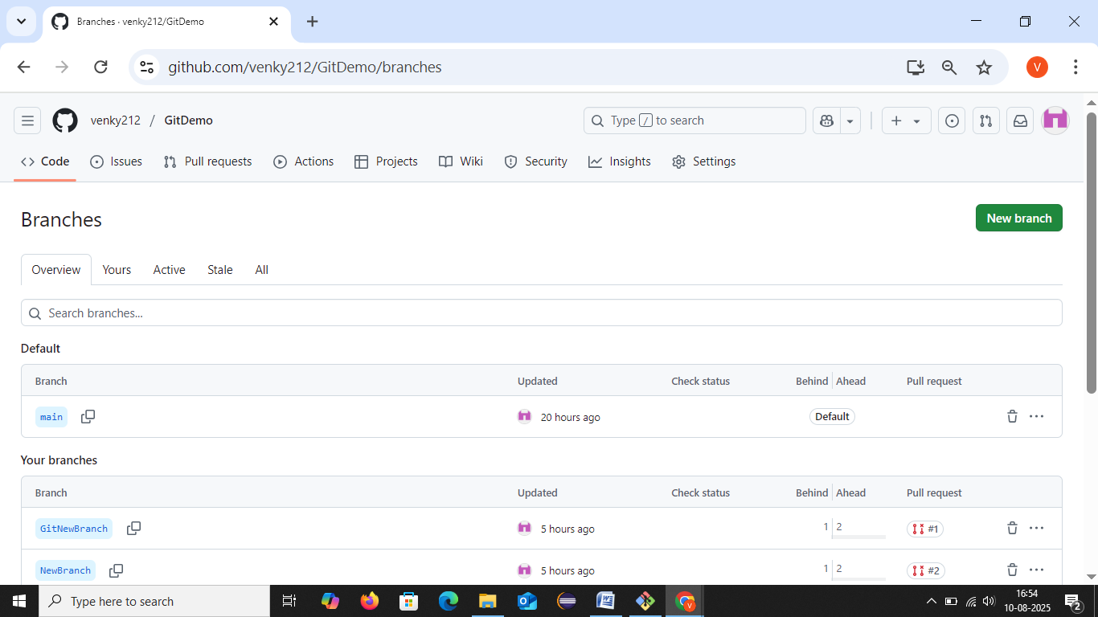

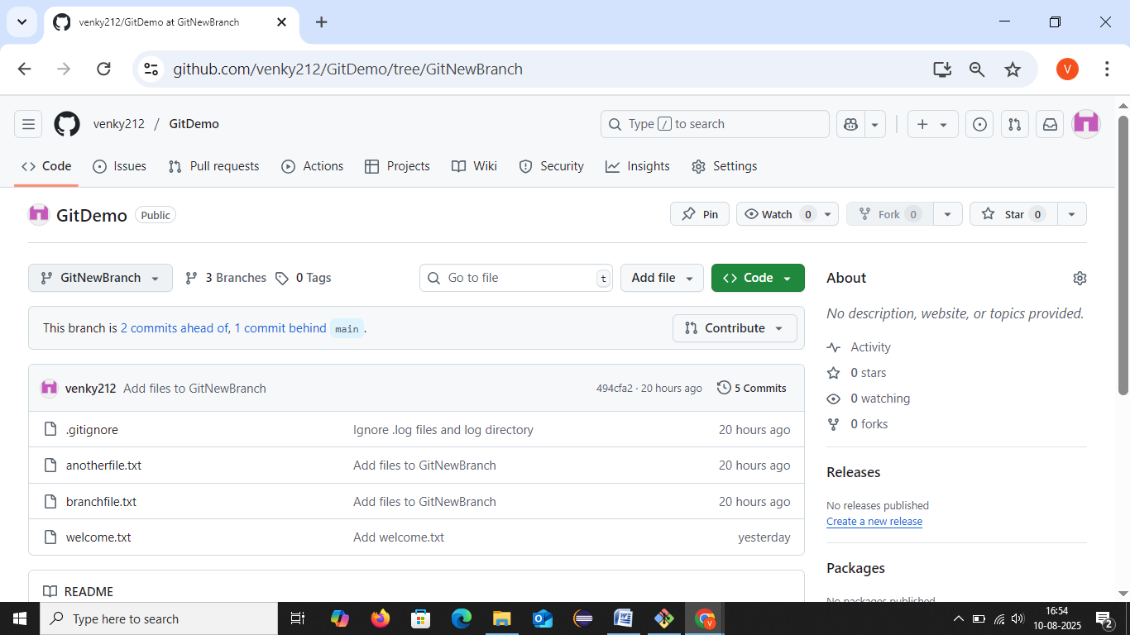

**Merging :**  
